AI Governance Tool — Solution Outline
ISED Innovative Solutions Canada — AI Decision-Making Process Visibility, Traceability and Compliance Governance (SSC sponsor)
Nov 2, 2026 · @Gladwin · HustleBench Advisory Services Inc. · DRAFT for discussion

1. Purpose and scope boundary
We propose a continuous AI governance engine that detects when a governance requirement or an AI system changes, works out which registered systems, controls and evidence are affected, and triggers a proportionate reassessment with explained, human-reviewed findings. It is built on open standards so it sits beside existing GC inventories, ML platforms and governance tools rather than replacing them.
In scope for TRL 5 (prototype validated in a simulated SSC-representative environment):
- A versioned library of governance requirements and controls for the five mandatory GC instruments plus NIST AI RMF as the extensibility proof.
- A registry of AI systems, populated through APIs and connectors, not manual re-entry.
- Change-driven impact analysis and reassessment triggering.
- Control assessment producing five-state, explained, confidence-scored findings.
- Human review, approval and audit trail on every finding and every requirement change.
- Ingestion of data, model and output risk measures from existing monitoring tools, evaluated against configurable thresholds.
- Remediation recommendations drafted for reviewer approval (optional capability, demonstrated not hardened).
Explicitly out of scope at this stage:
- Autonomous compliance decisions. AI assists interpretation and drafting; a named person approves every published control change and every finding.
- Building a new model-monitoring or explainability engine. We ingest results from tools departments already run (or open-source equivalents) and govern them.
- Explaining model internals. We record decision traces and explanations that model platforms emit; we do not reverse-engineer models.
- Legal advice. The tool maps and evidences requirements; interpretation authority stays with the department.
- ISO/IEC 42001 and EU AI Act content packs. The model supports them; they are roadmap items, not demonstrated.

2. Challenge interpretation
The innovation SSC is buying is not another inventory or questionnaire; it is reducing the manual effort of keeping governance current as requirements and systems both move. The notice names four manual pain points, and the solution answers each with a specific mechanism.
Manual effort named in the challenge | Solution mechanism | How it stays bounded
Interpreting evolving governance requirements | AI-assisted decomposition of a new or changed instrument into atomic obligations and draft controls, each linked to the source clause | Drafts only; a governance author approves before anything is published
Applying requirements to specific AI systems | Applicability rules driven by system attributes (intended use, AIA impact level, decision type, data classification, gen-AI or agentic) | Deterministic rules, authored and versioned; no opaque scoping
Updating controls and assessments | Versioned requirement and control library with diff between versions | Only changed obligations re-enter assessment
Identifying ecosystem-wide impact | Traceability graph from clause → obligation → control → system → evidence → finding | Impact is a graph query, so every "affected" result can be shown and explained
The phrase in the challenge that anchors the design is visibility into AI decision-making, traceability of AI outputs and compliance with Canadian law and international practice. We read this as three testable properties of the prototype:
- Visibility — for any registered system, a reviewer can see what it decides, on what basis, and what decision records exist.
- Traceability — any finding can be followed back to the clause that required it and forward to the evidence and approver that closed it.
- Compliance — the system shows current status against each applicable requirement and says, unprompted, when that status is no longer trustworthy.

3. Solution concept: the continuous governance loop
Governance runs as a loop triggered by change, not as an annual exercise. Every pass through the loop leaves an auditable record and ends with a person deciding.
- Sense — a change event arrives: a requirement is added, modified, replaced or retired; a system changes (model version, data source, intended use, deployment state); a monitoring threshold is breached; evidence expires; or a reviewer requests reassessment.
- Analyse impact — the traceability graph identifies affected systems, controls, evidence and prior findings, and classifies the change as notify-only, targeted reassessment or full reassessment.
- Reassess — only the affected controls are re-evaluated, using deterministic checks first and AI-assisted evidence review second.
- Explain — each finding states the requirement, evidence considered, result (Met, Partially met, Not met, Not applicable, Unable to determine) and a confidence measure, in English and French.
- Review — an authorised reviewer validates, rejects, modifies or annotates the finding; the decision is logged.
- Respond — for Not met or Partially met, the engine drafts a remediation recommendation; on approval it can raise a ticket in the department's case system. Closure evidence re-enters the loop at step 1.
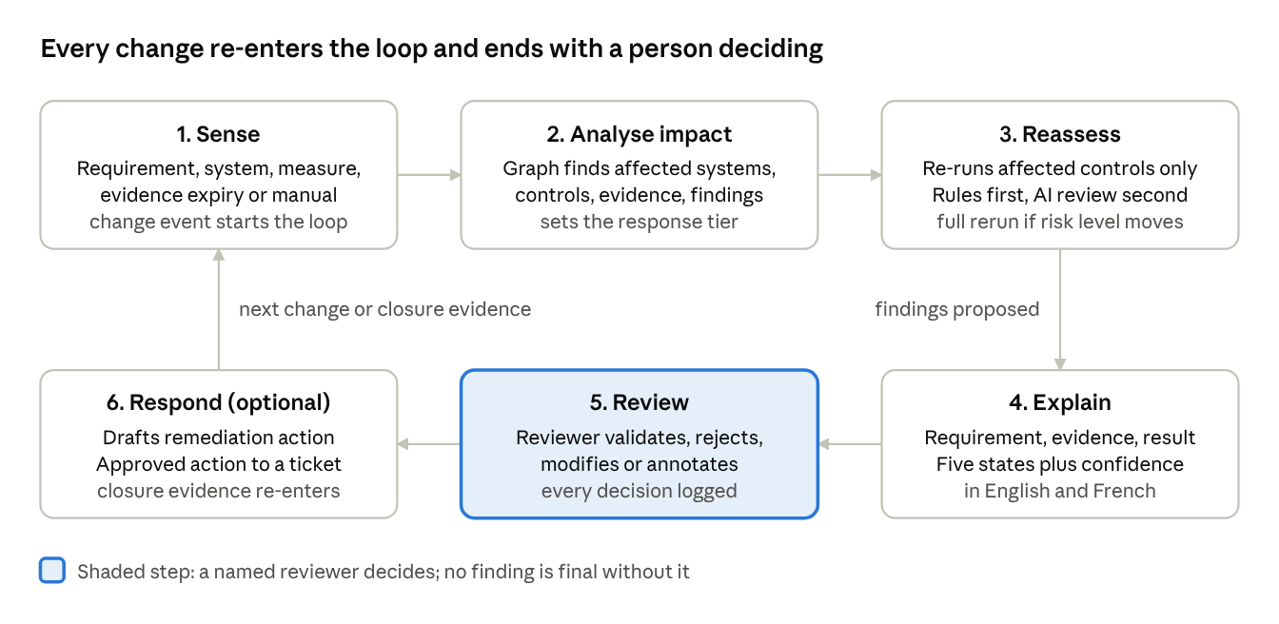
continuous governance loop · 6 steps, 1 human decision point
Steps 1 to 4 run automatically; step 5 is always a person; step 6 is optional at this stage and only acts after approval.

4. Logical architecture
Five layers, each built on a documented open standard or open-source component, with HustleBench's value concentrated in the requirement-to-control reasoning and the reassessment engine.
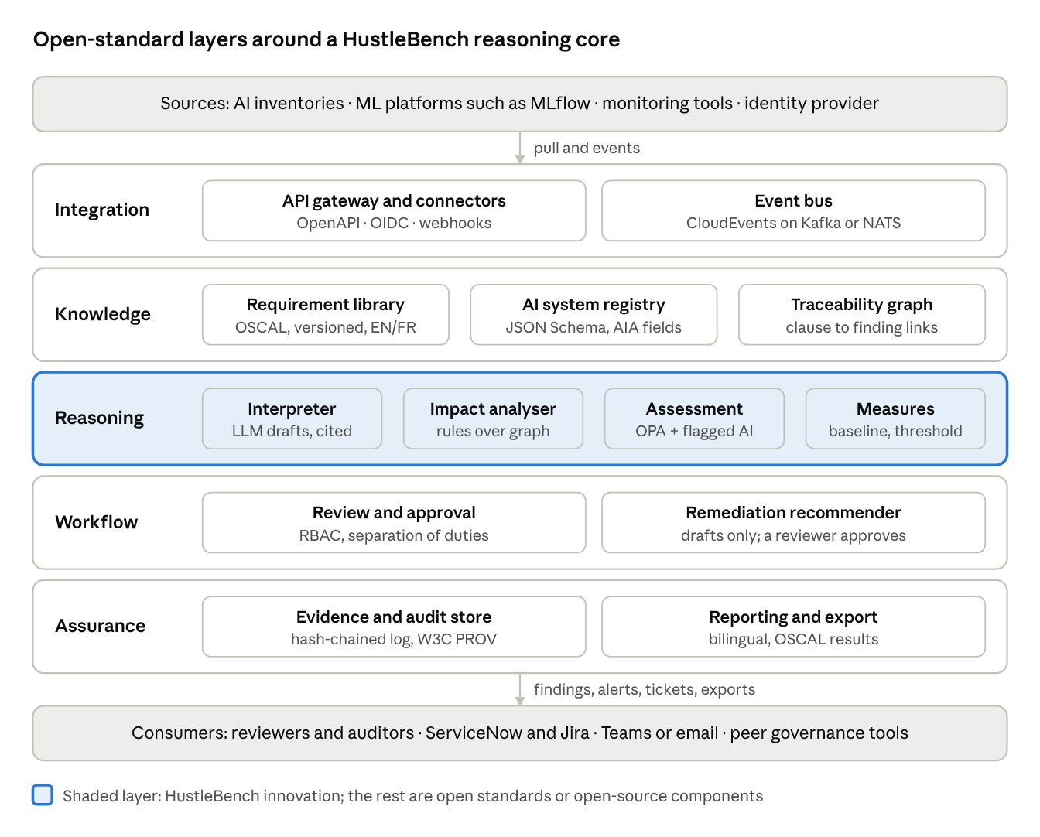
logical architecture · 5 layers
Only the reasoning layer is net-new IP; everything around it is replaceable with a department's existing equivalent.
Layer | Component | Role | Open standard or candidate technology
Integration | API gateway and connectors | Pull system metadata, decision traces, monitoring results; push findings, alerts, tickets | OpenAPI 3.1, OAuth 2.0 / OIDC, CloudEvents, webhooks
Integration | Event bus | Carries change events that start the loop | CloudEvents over Kafka or NATS
Knowledge | Requirement and control library | Versioned obligations, controls, assessment criteria, profiles per system group | NIST OSCAL (catalog, profile, component definition, assessment results)
Knowledge | AI system registry | System metadata: owner, intent, status, funding state, client, objectives, AIA level | JSON Schema; aligned to GC AIA fields and model-card conventions
Knowledge | Traceability graph | Links clause → obligation → control → system → evidence → finding | Property graph (PostgreSQL with Apache AGE, or Neo4j Community)
Reasoning | Requirement interpreter | Decomposes new or changed instruments into draft obligations and control mappings with source citations | LLM hosted in-tenant (open-weight or GC-approved), retrieval over the source text
Reasoning | Impact analyser | Graph traversal from a change to affected items; classifies response tier | Deterministic rules over the graph
Reasoning | Assessment engine | Evaluates controls against evidence; produces five-state results with confidence | Policy-as-code (Open Policy Agent / Rego) for deterministic checks; LLM for evidence review, flagged
Reasoning | Measures evaluator | Compares ingested data, model and output metrics to baselines and thresholds | Configurable rules; metrics from existing tools
Workflow | Review and approval | Validate, reject, modify, annotate; approvals, exceptions, attestations | BPMN-style workflow; RBAC/ABAC via Keycloak or departmental IdP
Workflow | Remediation recommender | Drafts remediation actions linked to the failed control | LLM drafting, human approval required
Assurance | Evidence and audit store | Immutable, hash-chained audit log; artefacts with provenance and submitter role | Object storage (S3-compatible), append-only log, W3C PROV for provenance
Assurance | Reporting | Dashboards, bilingual reports, OSCAL assessment-results export | Open formats (OSCAL JSON, CSV, PDF)
The split between deterministic and AI-assisted reasoning is deliberate: anything that decides applicability or impact is rule-based and reproducible; AI is used where text must be read and interpreted, and its output is always a draft or a flagged finding.

5. Governance knowledge model
Traceability depends on a small set of linked, versioned objects; every object carries an owner, a version, a status and a bilingual label.
Object | Key attributes | Lifecycle
Governance source | Instrument name, issuing body, effective date, clause references, EN/FR text | Added, modified, replaced, retired
Obligation | Atomic "must/should" statement, source clause, applicability conditions | Draft → approved → superseded
Control | Testable statement, assessment method (automated, evidence review, attestation), evidence expected | Versioned; mapped to one or more obligations
Profile | Set of controls for a system group (e.g. AIA Level III decision systems, gen-AI assistants) | Assigned to systems or groups
AI system | Metadata from the registry, attributes that drive applicability, linked models and datasets | Registered → in development → production → retired
Evidence | Artefact or reference, submitter, role, timestamp, hash, expiry | Submitted → accepted → expired
Finding | Control, result state, evidence used, rationale, confidence, reviewer decision | Proposed → reviewed → final; reopened on change
Action | Remediation, exception or attestation linked to a finding | Recommended → approved → closed
Versioning rule: a new requirement version never overwrites the old one. Findings stay pinned to the version they were assessed against, which is what lets the system show precisely which findings a change has made stale.

6. Continuous assessment, reassessment triggers and response
Every trigger is mapped to a response tier, so the engine does the least work that keeps findings trustworthy and never silently leaves a stale result in place.
Trigger | Example | Default response tier
Requirement added | New TBS guidance on generative AI is approved into the library | Targeted reassessment of systems whose profile now includes the new controls
Requirement modified | DADM clause amended | Targeted reassessment of findings pinned to the old version of that clause
Requirement replaced or retired | Superseded directive | Findings marked superseded; replacement controls assessed
System change | New model version, new data source, change of intended use or decision type | Targeted reassessment; full reassessment if AIA impact level changes
Measure breach | Fairness or accuracy metric crosses its threshold | Re-evaluate the linked controls; alert the system owner
Evidence expiry | Attestation older than its validity period | Finding moves to Unable to determine until renewed
Scheduled or manual | Annual review, auditor request | Full reassessment of the selected scope
Response tiers:
- Notify — the change is informational; owners are told, no findings change.
- Targeted reassessment — only affected controls are re-run; unaffected findings carry forward with their original approval.
- Full reassessment — the whole profile is re-run, used when the system's risk classification changes.
- Remediation recommendation (optional) — for each Not met or Partially met finding, the engine drafts an action: what to change, which evidence would close it, and who owns it. A reviewer accepts, edits or rejects it. Accepted actions can be raised as tickets; their closure evidence triggers a targeted reassessment of that control.
Tier thresholds are configuration owned by each department, not code.

7. Explainability, confidence and human oversight
Every finding is a self-contained, bilingual explanation a non-specialist reviewer can check without opening another tool.
Finding structure: applicable requirement and clause (with version) · control tested · evidence considered (with links and submitter role) · result state · rationale in plain language · confidence · assessment method · reviewer decision and history.
Five result states, with explicit rules:
State | Rule
Met | All required evidence present, current and satisfying the control criteria
Partially met | Some criteria satisfied; the unmet criteria are listed
Not met | Evidence shows the criteria are not satisfied
Not applicable | Applicability rule excludes the system; the rule is cited
Unable to determine | Evidence missing, expired, contradictory or confidence below the floor
Confidence measure is a transparent composite, not a model probability: assessment method (automated check high; AI-assisted evidence review capped), evidence coverage (share of expected evidence present), and evidence freshness. The components are shown alongside the score. Any AI-assisted finding below a department-set floor is routed to Unable to determine and to a reviewer.
Human oversight: no finding becomes final, and no requirement change is published, without an authorised reviewer's decision. Reviewers can validate, reject, modify or annotate; the original proposal, the change and the reason are all kept. AI-generated text is labelled as such throughout.
Decision visibility for registered systems: where a system emits decision records (inputs reference, model version, output, explanation), the platform ingests and links them to the system and its findings, so a reviewer can sample real decisions as evidence. This uses OpenTelemetry and OpenLineage-style events from the source platform; it does not generate explanations itself.

8. Data, model and output risk monitoring
The platform governs measures rather than computing them: departments define which measures matter for each system, set baselines and thresholds, and the platform ingests results, evaluates them, keeps the history and feeds breaches into reassessment.
Risk area | Example measures (configurable per system) | Typical source
Data | Completeness, representativeness of protected groups, drift from training baseline, data lineage present | Data quality tools, OpenLineage, Evidently or equivalent
Model | Accuracy or error rate against baseline, performance by subgroup, version change | MLflow or the department's ML platform registry
Output (predictive) | Fairness metrics, consistency across similar cases, override rate by human decision-makers | Fairlearn or equivalent; case-system data
Output (generative and agentic) | Groundedness, refusal and safety violation rate, prompt-injection test results, tool-call audit coverage | LLM evaluation harness results; gateway logs
Each measure carries a baseline, a threshold, an owner and the control it evidences. A breach creates a traceable issue record, updates the linked finding and starts the reassessment path in section 6.
For the TRL 5 demonstration we will supply reference connectors for two sources (an MLflow registry and an open-source drift and fairness library), with synthetic data. Other tools connect through the same documented ingestion API.

9. Interoperability, integration and data exchange
All governance information moves through documented, versioned interfaces so departments can integrate with minimal customization and leave without losing their data.
- Inbound (collect and aggregate): REST APIs with OpenAPI specifications for system registration, evidence submission and metric ingestion; event subscriptions (CloudEvents) for change notifications from ML platforms and CI/CD; scheduled pull connectors for inventories and registries.
- Outbound (share): OSCAL assessment-results and plan-of-action exports; webhooks and events for findings, alerts and approvals; JSON and CSV bulk export of everything the tenant owns.
- Reconciliation: when the same system appears in several sources, the registry keeps one record with source attribution per attribute and flags conflicts for the owner rather than overwriting.
Reference connectors for the demonstration:
Target | Direction | Purpose
Departmental AI inventory (simulated, CSV or API) | Inbound | Seed and synchronise the registry
MLflow model registry | Inbound | Model versions, metadata, metrics
Open-source drift and fairness library | Inbound | Data and output measures
ServiceNow and Jira | Outbound | Approved remediation actions as tickets
Microsoft Teams or email | Outbound | Alerts and review requests
Peer governance tool (OSCAL file exchange) | Both | Prove interoperability with other governance solutions
The connector SDK and API specifications are published, so a department or a third party can add a connector without vendor involvement.

10. Security, sovereignty, tenancy, bilingualism and deployment
The platform is designed to run entirely inside a GC-controlled environment, including the language model, so no governance data or source text leaves the tenant.
- Access control: RBAC with attribute conditions (tenant, system group, classification); SSO through the department's identity provider (OIDC or SAML); separation of duties so an evidence submitter cannot approve their own finding. Every artefact records who provided it and in what role.
- Administrative access: privileged actions require step-up authentication and are logged to the immutable audit store; support access is time-bound and approved by the tenant.
- Data residency, retention and deletion: tenant administrators set residency location, retention periods per object type and deletion rules through the UI, without vendor intervention. Deletions are logged with the approving user.
- Multi-tenancy: each department is a tenant with its own requirement library extensions, profiles, thresholds, reviewers and reports, on a shared platform with logical isolation and per-tenant encryption keys.
- Bilingualism: EN/FR interface, notifications, reports and finding explanations; governance sources held in both official languages and linked clause by clause.
- Deployment: containerised (Kubernetes and Helm), no hyperscaler-specific services in the core, so the same build runs on-premises, in private cloud or in Canadian-hosted public cloud. The LLM is pluggable: an open-weight model served in-tenant, or a GC-approved endpoint.
- Security posture: the TRL 5 demonstration runs in a Protected B environment aligned with ITSG-33 controls. HustleBench prepares the security assessment evidence; formal authorisation to operate remains with SSC.

11. Traceability to the challenge outcomes
Every essential outcome maps to a named component and a demonstration step, so evaluators can test each claim.
# | Essential outcome (abridged) | Components | Section
E1 | Continuous alignment; identify affected systems; signal reassessment | Impact analyser, event bus, traceability graph | 3, 6
E2 | Interoperability with enterprise, AI/ML and governance tools, minimal customization | API gateway, connectors, OSCAL exchange | 9
E3 | Standards-based APIs and data exchange of governance information | OpenAPI, CloudEvents, OSCAL | 4, 9
E4 | Collect, aggregate, maintain across systems | Registry with source attribution and reconciliation | 9
E5 | Open standards, reduced proprietary dependency | Open-source core, pluggable LLM, open formats | 4, 10
E6 | Restricted, monitored, controlled access per GC requirements | RBAC/ABAC, step-up auth, audit store | 10
E7 | Tenant-managed residency, retention, access, deletion | Tenant administration | 10
E8 | Assessment and reassessment as requirements change; requirements to traceable controls; non-conformities | Requirement interpreter, assessment engine, versioned library | 5, 6
E9 | Add, modify, version, replace, retire requirements and frameworks; assign to systems or groups; GC instruments | Library, profiles; GC content pack | 5, 12
E10 | Different criteria by intended use and risk; extensible to NIST, ISO, EU AI Act | Applicability rules, profiles; NIST AI RMF pack | 2, 5, 12
E11 | Human-readable findings with requirement, evidence, result, confidence | Assessment engine, explanation template | 7
E12 | Collect, link, retain assurance artefacts with authorised-provider identification | Evidence and audit store, RBAC | 5, 10
E13 | Met, partially met, not met, not applicable, unable to determine | Assessment engine rules | 7
E14 | Reviewers validate, reject, modify, annotate with audit history | Review and approval workflow | 7
E15 | Risks from data, models and outputs feed governance | Measures evaluator | 8
E16 | Data risk and quality baselines, thresholds, traceable issues | Measures evaluator, issue records | 8
E17 | Configurable risk, performance and quality measures | Measures configuration | 8
E18 | Output evaluation: accuracy, quality, fairness, consistency, safety | Ingested evaluation results, thresholds | 8
Additional outcomes — deployment flexibility, bilingualism, multi-tenancy, and reporting with collaboration and ticketing integration — are covered in sections 9 and 10.

12. TRL 5 demonstration plan and success criteria
TRL 5 is shown by running the integrated prototype end to end in a simulated SSC-representative Protected B environment, with realistic integrations and synthetic but plausible AI systems.
Starting point (TRL 4): HustleBench's delivery methodology and the engagement assets it uses on GC transformation work, which define the governance processes the prototype automates.
Phase 1 plan — 18 months, CAD $2 million, delivered solely by HustleBench:
Months | Phase | Exit gate
1–3 | Foundation: Protected B environment, knowledge model, AI system registry, MLflow connector, GC content pack drafted | Environment accepted by SSC; content pack reviewed
4–7 | Core engine: requirement interpreter, impact analyser, assessment engine, five-state findings, review workflow | Scenarios 1 and 2 run end to end
8–11 | Monitoring and integration: measures evaluator, ServiceNow and Jira, Teams and email alerts, OSCAL exchange, two tenants, EN/FR | Scenarios 3 and 4 run; connectors work against documented APIs
12–14 | Extensibility and response: NIST AI RMF pack, remediation recommender, reporting | Scenarios 5 and 6 run
15–18 | TRL 5 validation with SSC: full scenario runs, success-criteria measurement, security assessment evidence, final report | TRL 5 evidence package accepted
A cost breakdown by phase and role will be built against the CAD $2 million envelope.
Demonstration environment: a Protected B, Canadian-hosted Kubernetes cluster built and operated by HustleBench; two tenants (two simulated departments); a portfolio of about a dozen synthetic AI systems spanning AIA levels I to IV, including predictive, generative and agentic examples; content packs for the Policy on Service and Digital, Directive on Automated Decision-Making, Algorithmic Impact Assessment, the GC AI Strategy and the guide on responsible use of AI, plus NIST AI RMF.
Scenarios evaluators will witness:
- Onboard — systems flow in from the simulated inventory and MLflow; profiles are assigned by applicability rules; baseline assessment runs.
- Requirement change — a modified DADM clause is loaded; the interpreter drafts obligations and controls with citations; an author approves; the impact analyser lists affected systems and stale findings; targeted reassessment runs.
- System change — a model version and intended-use change on one system raises its AIA level; full reassessment is triggered.
- Measure breach — a fairness threshold is crossed; the linked finding moves to Not met; an alert and review request are sent.
- Review and respond — a reviewer modifies one finding and rejects another; a remediation recommendation is approved and raised as a ticket; closure evidence triggers reassessment to Met.
- Extensibility — NIST AI RMF is added and assigned to one tenant only, showing per-tenant frameworks.
- Audit — an auditor traces one finding from clause to evidence to approver, and exports OSCAL results in English and French.
Success criteria (targets to be agreed with the technical authority):
Measure | How it is tested
Impact accuracy | Affected systems and findings identified by the engine compared with an expert-prepared answer key
Effort reduction | Analyst time to process a requirement change, with and without the tool
Explanation quality | Reviewer rating of finding clarity and completeness, EN and FR
Traceability completeness | Share of final findings with an unbroken clause-to-approver chain
Interoperability | Connectors working against documented APIs with no code change to the core
Oversight integrity | Zero findings or requirement versions published without an authorised approval

13. Risks, assumptions and open questions
Risk | Effect | Mitigation
LLM misreads a requirement or evidence | Wrong draft control or finding | Drafts only, source citations, confidence cap, mandatory human approval, answer-key testing
GC instruments change during the project | Content pack goes stale | That is the use case: changes are loaded and processed as demo scenarios
Departmental tools vary widely | Connectors multiply | Publish one ingestion API and SDK; build two reference connectors only
Scope creep into monitoring or explainability engines | Effort diverted from the innovation | Govern ingested measures; integrate rather than build
Overstated automation claims | Credibility with evaluators | Every capability demonstrated live against the success criteria
Assumptions:
- The demonstration runs in a Protected B environment using synthetic systems and data handled as Protected B; no live departmental data is needed to reach TRL 5.
- An in-tenant LLM of moderate size is sufficient for requirement decomposition and evidence review with retrieval.
- OSCAL can represent GC policy instruments with modest extension (applicability conditions, bilingual text).
Decisions confirmed (2 Nov 2026):
Topic | Decision | Effect on the outline
TRL 4 baseline | HustleBench delivery methodology and the engagement assets used on GC work | Cited as the starting point in section 12
Delivery model | Delivered solely by HustleBench, no partners | HustleBench hosts the LLM and builds the OSCAL tooling on open-source components
Phase 1 envelope | 18 months, CAD $2 million | Phase plan in section 12
Reference connectors | ServiceNow and Jira | Both built for the demonstration (section 9)
Environment | Protected B | Demonstration runs in a Protected B environment (sections 10 and 12)

